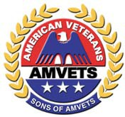
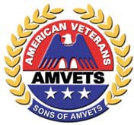
SONS OF AMVETS
DEPARTMENT OF FLORIDA
Veterans Mobility Assistance Program Application

With the ongoing support of grants provided by the AMVETS Department of Florida Service Foundation,
the Sons of AMVETS Department of Florida is committed to assisting our nation’s Veterans through our Veterans Mobility Assistance Program. All requests for assistance will be reviewed by the Sons of AMVETS Department of Florida Executive board. Please provide the information below and forward your request to the SOA Department of Florida Commander by e-mail or by USPS mail. (addresses below).

Date: / /

Date of birth: / / Name:

Address:

City:
State:
Zip Code:

Phone:
Height:
Weight: (models vary according to an individuals size)

Veterans Service Organization Member (AMVETS, VFW, American Legion)? Post#

What years did you serve? Branch of service:

Briefly describe your duties, stations of service and any awards received:

Briefly state reason for requesting a unit.

Signature
The Sons of AMVETS Department of Florida is not liable for or responsible for the maintenance/repair of the unit or for any property damage or bodily injury resulting from the operation of this equipment. Your signature above acknowledges your agreement with the above liability statement
SOA Dept. of FL Commander Nathan Wuesthoff
3886 Prescott Loop
Lakeland, FL 33810 nathancomar@live.com (863) 808-8273

Please send this completed form to:
SOASOA

. (08-25-2021)

